

CUSTOMER CARE REGISTRY

**CUSTOMER JOURNEY MAP**

# TEAM DETAILS:



**Team No :** PNT2022TMID46076

**College Name :** University college of Engineering

**Department :** Computer Science & Engineering

# PROBLEM MEMBERS :

* T.ABARNA
* V.MENAGA
* S.ANITHA
* S.SUJI

Customer Journey Map 2

# PROJECT DESIGN PHASE –II

**CUSTOMER JOURNEY MAP**

|  |  |
| --- | --- |
| **DATE** | **03 NOV 2022** |
| **TEAM ID** | PNT2022TMID46076 |
| **PROJECT NAME** | CUSTOMER CARE REGISTRY |
| **MAXIMUM MARKS** | 4 Marks |

Customer Journey Map 3

|  |  |  |  |  |  |
| --- | --- | --- | --- | --- | --- |
| **STAGE** | **AWARENESS** | **CONSIDERATION** | **DECISION** | **SERVICE** | **LOYALTY** |
| CUSTOMER ACTIVITIES | see social media campaign  Hear about from  friends | Conduct reach, compare features and pricing | Make a purchase | Contact customer service, Documentation, read product and service | Share the experience |
| TOUCHPOINTS | Social media, Traditional media , word of mouth | Social media, Websites | Website, Mobile app | Chatbot, Email notification | Social media,word of mouth Review sites |
| CUSTOMER  EXPERIENCE | Interested, Hesitant | Curious, Excited | Excited | Frustrated | Satisfied, Excited |
| KPIS | customer feedback | New website visitors | Conversional rate | Waiting time, customer service score | Customer satisfaction score |
| RESPONSIBLE | Communications | Communications | Customer service | Customer service | Customer service,  Customer success |

Customer Journey Map 4

  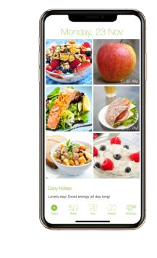

**Useí Issue have to Registeí in**



**Useí can tíack the**

**Useí fiíst Login**

**the web poítal**

**issue in the Web Poítal**

**Logout**

**0**

**1**

**2**

**4**

**3**

**5**

5

Customer Journey Map

Personalised Recommendation

After experiencing our user friendly website,the customer can share information .

Customer email

Help to customer get solution for their problem

Agent should solve customer’s problem

Waiting an hold for too long

Offer fast support

Reduce waiting time

Customer Journey Map

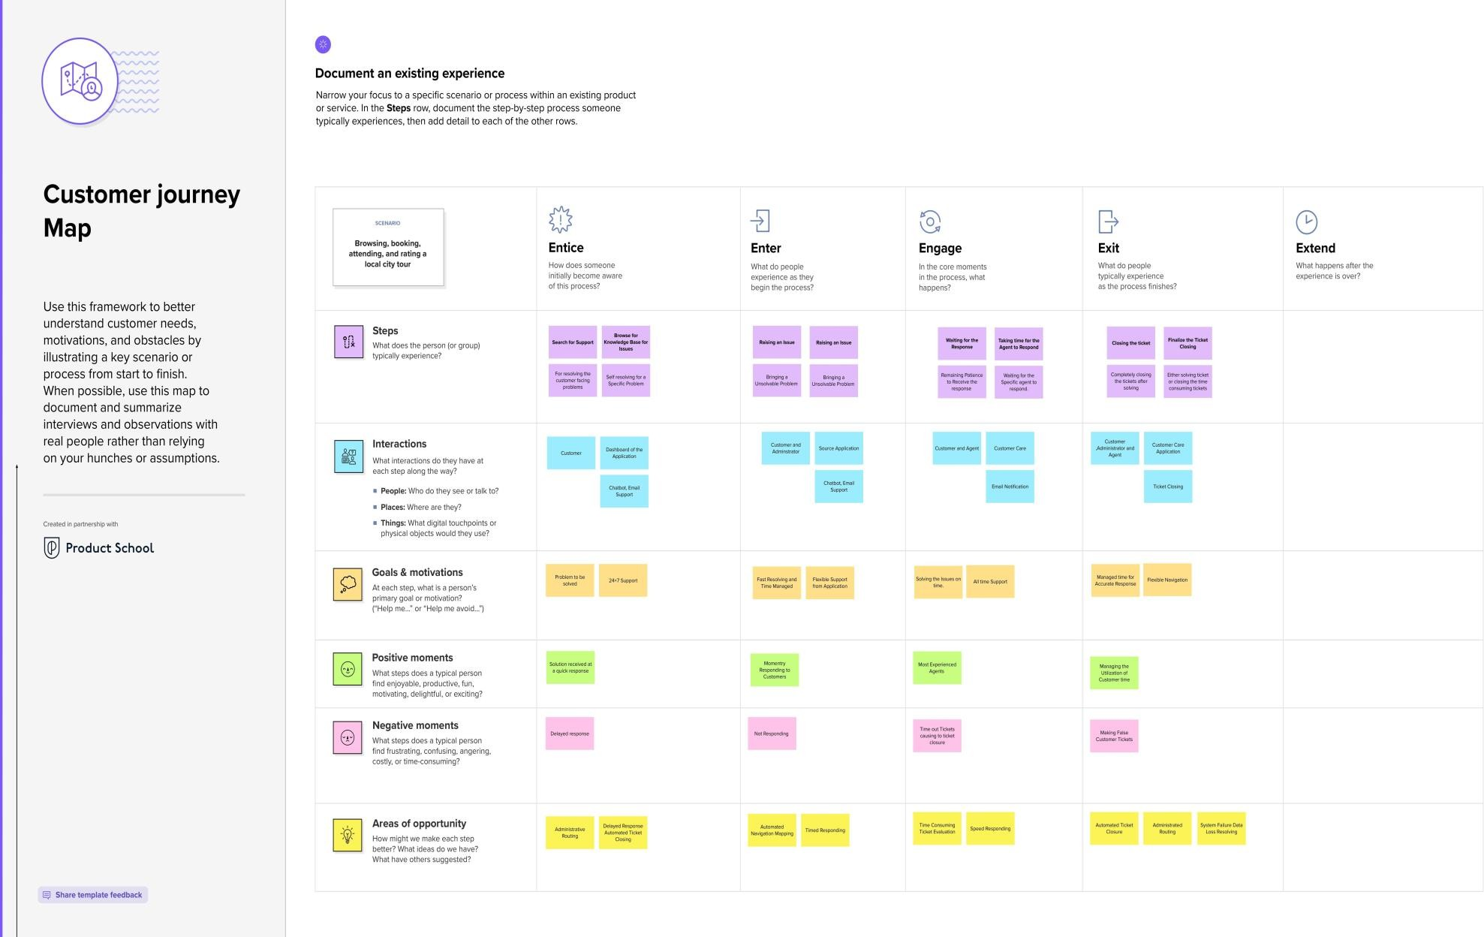

**Thank you**